FULL ADDER

AIM: To implement the fulladder using logicism.

INPUT:

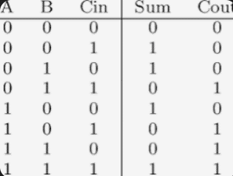

OUTPUT:

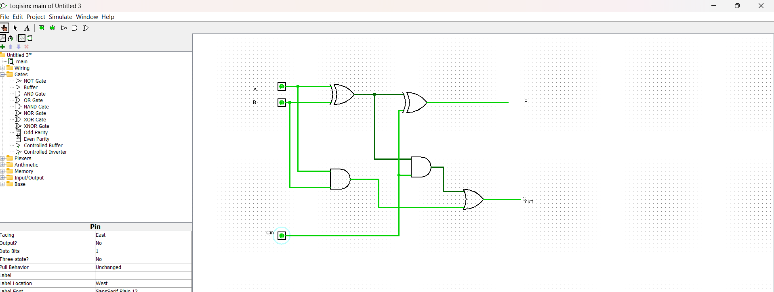

RESULT: Thus the program was executed successfully using logic sim.